5th Battalion Duke of Cornwall Light Infantry

Explanation of Resource Spreadsheet

Purpose

The most important qualifying point regarding this work is that it is a snapshot in time and can only provide so much information, it is a work in progress. It may be an ideal starting point for anyone wishing to research the 5th Battalion but by no means can it be considered a full record.

This work was initially an attempt to list those soldiers of the 5th Battalion who were Killed in Action during the campaign to liberate Western Europe during 1944-45 as recorded in the Battalion War Diaries. It soon became obvious that such a list was limited in usefulness, after all much of this information is available from the superb Commonwealth War Graves Commission (CWGC) website. In addition, many lists and part lists were found in the archive of Bodmin Keep with the limitation that these documents were not 'digital' and not generally available for those who might be interested. Finally, the availability of information from further sources meant that what started as a simple idea required a definition of purpose so that anyone using the spreadsheet would be aware of the information it contained, its limitations and any signposts to additional resources.

It is vital to remember that this resource is NOT complete and is best viewed as a work in progress, it is hoped that updated lists will be uploaded twice a year.

We would encourage anyone with additional information to get in touch.

Definition of Purpose

- To provide as complete a list as possible of those who served with the 5th Battalion Duke of Cornwall's Light Infantry between the start of World War II and the completion of the War Diary on 31.12.1945.
- To act as a resource for research into the Battalion by both listing relevant information and indicating where further information can be found.
- Ultimately to aim to have a complete record that can be interrogated for demographic information.

Conventions

Whilst a spreadsheet is extremely valuable it does have limitations and to obtain further usefulness some work arounds are used. A good example is the Prime Record column. For individuals who have multiple mentions in the spreadsheet their first mention is labelled Y all other being labelled N. The Prime line is also used to place important facts such as any awards, place of birth or those unfortunate to be wounded or killed in battle. A simple filter, choosing Y within the Prime Filter column lists the total number of soldiers that served in the Battalion between 3.9.1939 until 31.12.1945 (2314 as of 4.5.2022). Using the Y filter will also enable in time (don't forget this is a work in progress) other useful information to be collated.

Multiple numbers
Occasionally there are records that either have multiple SN (Service Number) or even surnames. Quite simply this is because such anomalies have been found in the various records consulted, even within the War Diaries.

Glossary - Column Headings

Prime Record
The primary information line of an individual soldier is labelled Y so that simply filtering by Y will give a definitive list of those who served, as a further aid to identification Primary rows are coloured light green. As of 4th April 2022, 2314, individuals have been listed that served in the 5th DCLI between 3.9.1939 until 31.12.1945, undoubtedly this number will grow. Subsequent lines have been labelled N and will include additional information from both the War Diaries and other sources. The screenshot below shows the filter applied on the surname field for 'Adams' and the resultant list shows four individuals, two of which have additional rows of information.

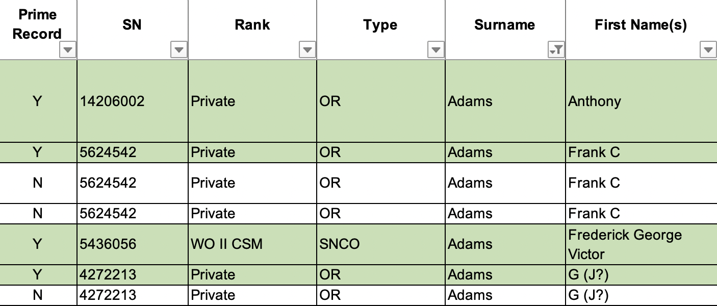

SN
The Service Number of the individual soldier.

Rank
The rank of the soldier which can vary throughout the service history of the individual. The last known held rank is shown within the primary row.

Type
The hierarchy within the Army can be broken down into many forms but possibly the most well-known is that of the authority of the individual from Officers to OR (Other Ranks). It might be that such an area would add a layer of demographic information, but caution needs to be applied because of the movement within the ranks and between sub-units within the Battalion. The individual entities used within the spreadsheet are below

NCO | Non-Commissioned Officer
Officer | Commissioned Officer
OR | Other Rank
SNCO | Senior Non-Commissioned Officer (Essentially an NCO with a Warrant)

Surname and First Name
The names of individuals or in some cases initials of first names. In some instances, there are multiple entries for the different spellings encountered in the War Diary or alternative source. In time it is hoped a cross referencing or perhaps even investigating an individual Army record will eliminate the double entries.

Award(s)
A simple listing of the awards earned by the individual concerned. Sometimes the location or action in which the award was earned or the confirmation of the award in the London Gazette is shown. Abbreviations used are as below.

MiD | Mentioned in Despatches
MC | Military Cross
MM | Military Medal
CBE | Commander of the Order of the British Empire
DCM | Distinguished Conduct Medal
DSO | Distinguished Service Order
CinC Certificate | Commander in Chief Certificate
LG | London Gazette
OBE | Order of British Empire
MBE | Member of British Empire
Mil. | Military

Earliest Date
'Earliest Date' is not necessarily the individual’s enlistment (joining) date and can simply reflect the first occurrence within one of the lists consulted. If a particular individual is of interest, it is advisable to investigate further. This can only be achieved by consulting the Army Records which are held by the Ministry Of Defence or one of the well-known commercial companies.

There is a large amount of movement within the Battalion, between Companies for example. It is also quite possible that the first mention of a soldier is found in the later diaries, some even relate to those being released back into civilian life after long term service, without prior mention in the earlier Diaries.

Event
What happened, when known, to the individual.

KiA | Killed in Action
WiA | Wounded in Action (x2 or x3 - denotes twice or three times wounded)
PoW | Prisoner of War
DoW | Died of Wounds
MiA | Missing in Action
Battle Exhaustion | This term covers many aspects of what today might be termed PTSD. However, it should be pointed out this is not conclusive and the term fatigue, rested might be pointers to the same condition. Further research would be required.

Event Date
The date, when known, that the event occurred, usually this is limited to wounding, becoming a prisoner, or being killed.

Event Location
The location or Battle in which the individual met their fate.

Age
When known, the age of the individual at the time of the related event.

Town or City
The place from where the individual either enlisted or primarily where they were born.

County, Area or Country (based on 1944 boundaries)
Possibly, used in conjunction with Town or City this column will be useful for research. Area primarily relates to London and relates to districts, for example Lambeth.

Company, Sub Unit and Role
The sub section of the Battalion in which the individual served.

War Diary and Page
The War Diary number relates specifically to the actual required diary. The Page number relates to the physical page number rather than any reference number used within the War Diary. This should make it simple to reach the correct page quickly. Where the phrase 'Nil' is used there is no reference within the War Diary, but the information has been found from elsewhere, for example on one of the other lists that have been used, in some cases the document is named in red which should assist searching the archives at Bodmin Keep for the relevant information.

Notes
Free text area for additional information which usually, but not always relates to the War Diaries. In some cases, useful lists can be found due to consistency of entry. For example, choosing the two following entries will list the Officers of the Battalion as of 8.1.1944.

First Field Return of Officers 8.1.1944 (Posted from Dorset Regiment, not yet joined)
First Field Return of Officers 8.1.1944

Listings
Key lists used to collate the information found within the spreadsheet (in addition to the War Diaries). The table below gives the various list details together with the location within the museum.

Key | Accession or Archive Number and location at The Keep
Casualty Roll | 2019.0143 Ground Floor, Archive, Cabinet 4, Drawer 1, Casualty List 1944 - 1945
D Company image/list | 2021.0037 Ground Floor, Archive, Cabinet 4, Drawer 1, Crowhurst 1944
Lever Document | 2021.0028 Ground Floor, Archive, Cabinet 4, Drawer 1, Normandy
List 005 | Archive_0665 Ground Floor, Archive, Cabinet 4, Drawer 1, Casualty List 1944 - 1945
Yellow Page A5 list | Archive_0666 Ground Floor, Archive, Cabinet 4, Drawer 1, Casualty List 1944 - 1945

Accession Number
Again, by no means complete but any images or associated documentation Bodmin Keep has within its archive will be listed here using the Accession Number. Using this number, it will be possible to reveal additional information held by the museum.

Cemetery, Plot. Row. Grave.
The human cost, information of the individual who lost their life in the conflict. Much of this information is to be found, as mentioned above, on the CWGC website.

CWGC Check
Cross reference check for those Killed in Action using the Commonwealth War Graves Commission website.

Conclusion

As already mentioned, this is a 'work in progress' and indeed this is just the start of a large piece of work. Further information, updates, corrections, or amendments are always welcome and can be emailed to

andrew@bodminkeep.org

4.5.2022
Abbreviations

Abbreviation | Term | Description
2iC | Second in Command | Relates to the Battalion or the Companies
A/U/Cpl | Acting Unpaid Corporal | Relates to promotion of an individual, in this instance to that of Corporal. The standard abbreviation for the rank is used, in this example Cpl, which if found elsewhere refers to the rank of Corporal.
A/U/L Cpl | Acting Unpaid Lance Corporal
A/U/L Sjt | Acting Unpaid Lance Serjeant
A/U/Sjt | Acting Unpaid Serjeant
Bn | Battalion | 5th Battalion Duke of Cornwall's Light Infantry
CinC Certificate | Commander in Chief Certificate
Coy | Company | Sub-unit of the Battalion
DCM | Distinguished Conduct Medal
DoW | Died of Wounds
DSO | Distinguished Service Order
KiA | Killed in Action
LG | London Gazette
MBE | Member of British Empire
MC | Military Cross
MiA | Missing in Action
MiD | Mentioned in Despatches
Mil. | Military
MM | Military Medal
MT | Motor Transport
NCO | Non-Commissioned Officer | Any rank between Lance Corporal to Serjeant
OBE | Order of British Empire
OC | Officer Commanding | The Battalion Commander
OiC | Officer in Command | OC is reserved for the Officer Commanding (or CO Commanding Officer). The term OiC therefore applies to Company or Platoon level.
OR | Other Ranks
PoW | Prisoner of War
SNCO | Senior Non-Commissioned Officer | Defined with a WO I or WO II classification
TA | Territorial Army
WiA | Wounded in Action
WO | Warrant Officer

